DeerCamp Legacy Collection – Traditions
- 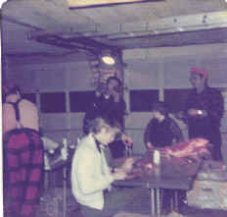
Cornell, WI – Venison butchering

- 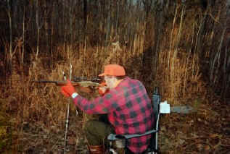
Colby, WI – Deer rifle sight-in

- 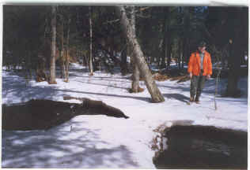
Drummond, WI – Spring scouting/shed hunting

- 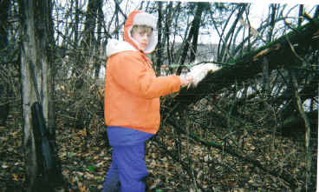
Eau Claire, WI – Chris hanging bucknuts

- 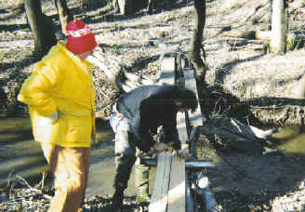
Elk Mound, WI – bridge building over creek

